FNB CAS – Data extract

**STEP 1:** Navigate to *https://fnbccard.revenuered.com/General/Common/DebtSearchand* and login using provided credentials.

**STEP 2:** Using the accompanying excel sheet (as seen below) loop through the rows to get the required/relevant information.



**STEP 3:** Enter the szAccountNumber (Col A above) from the excel sheet.

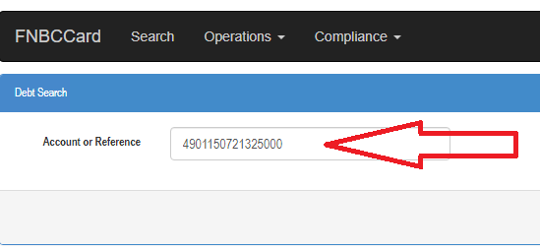

**STEP4:** Click the search button on the far-right hand side.

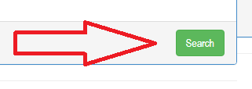

**STEP5:** Once on account page, verify that the account number was entered correctly by matching to what was entered in step3.

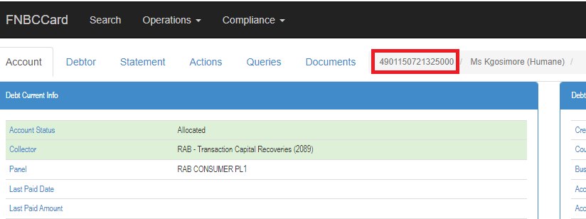

**STEP6:** If account number is entered correctly, Extract the highlighted field data:

Fields to be provided:

*Last Paid Date*

*Last Paid Amount*

*Last Paid Date at Handover*

*Last Paid Amount at Handover*

**STEP7:** Proved excel document with extracted information

*Repeat these steps for all the rows in excel sheet until they are all processed.*